NAME: SANJOT SINGH

STUDENT ID: 100416640

EMAIL ID: sanjotsingh@email.kpu.ca

WEBSITE URL: <https://sites.google.com/view/sanjot-singh-sidhu>

Use case diagram:

\*Prototype interface 9 (by me and Akash)

\*Review class diagram:

• Vegetable methods include add Vegetable(), edit Vegetable(), delete Vegetable(), update Vegetable(), save Vegetable(), and search Vegetable().

• Add Store(), edit Store(), delete Store(), update Store(), save Store(), and search Store() are all store methods ()

• Stock methods include add Stock(), edit Stock(), delete Stock(), update Stock(), save Stock(), and search Stock()

\*Relational database:

Registration page: -

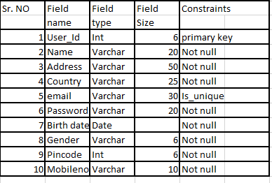

Work experience:

Working with this group (Amrit, Akash, And Sagar) was a great experience. We motivated and helped each other.

There are many things that everyone does not know about them. So we learn many things from others regarding this project or class.